Join two tables in dataflow

1. Create source 1 similarly like we created previously
2. Now scroll down and add another source

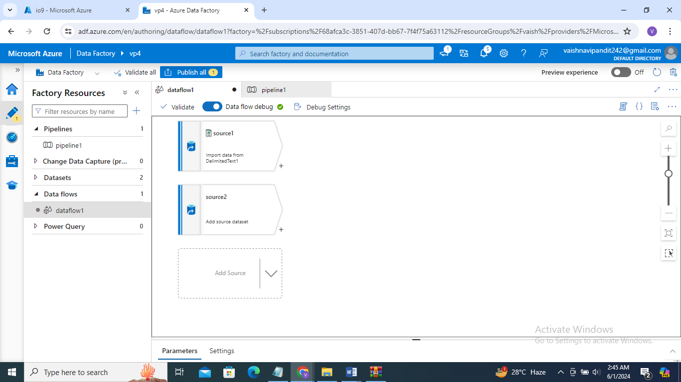

1. Now add datasets to both

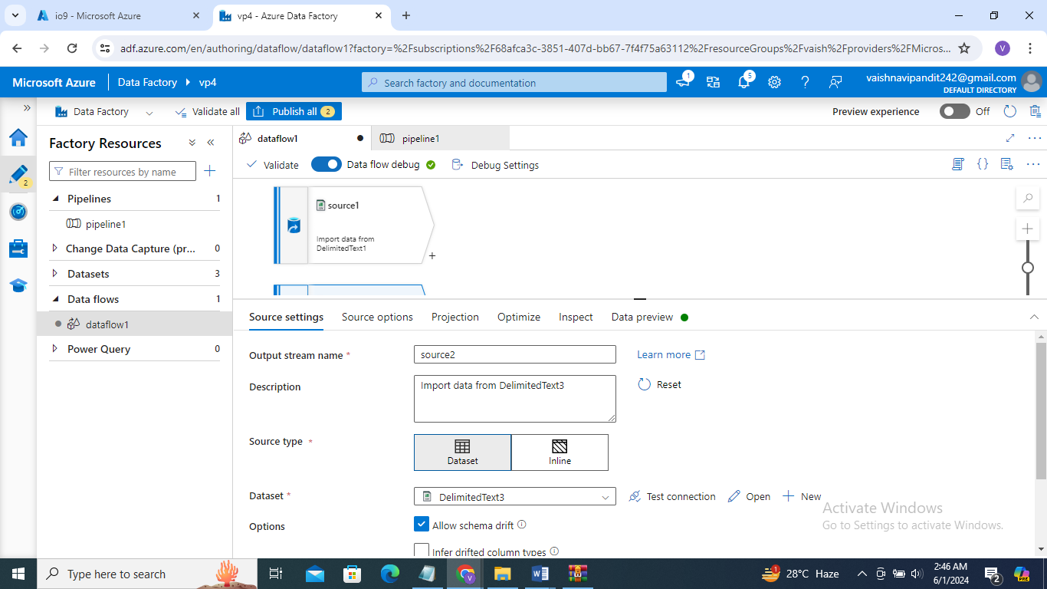

1. Now click on + after source 1 select join

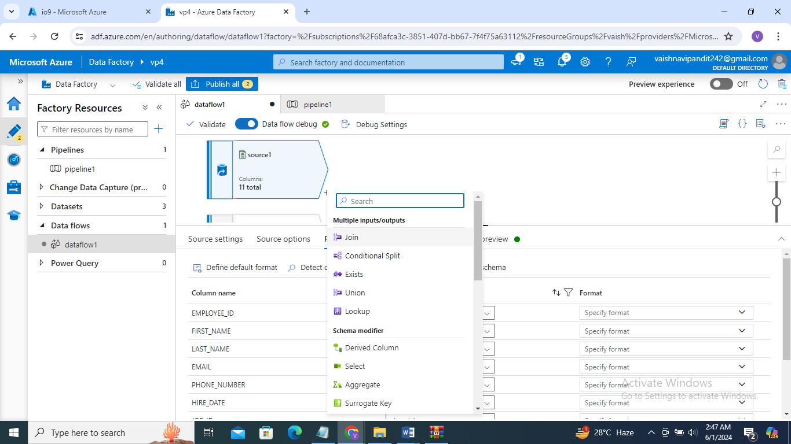

1. Now go to join add right stream as source 2

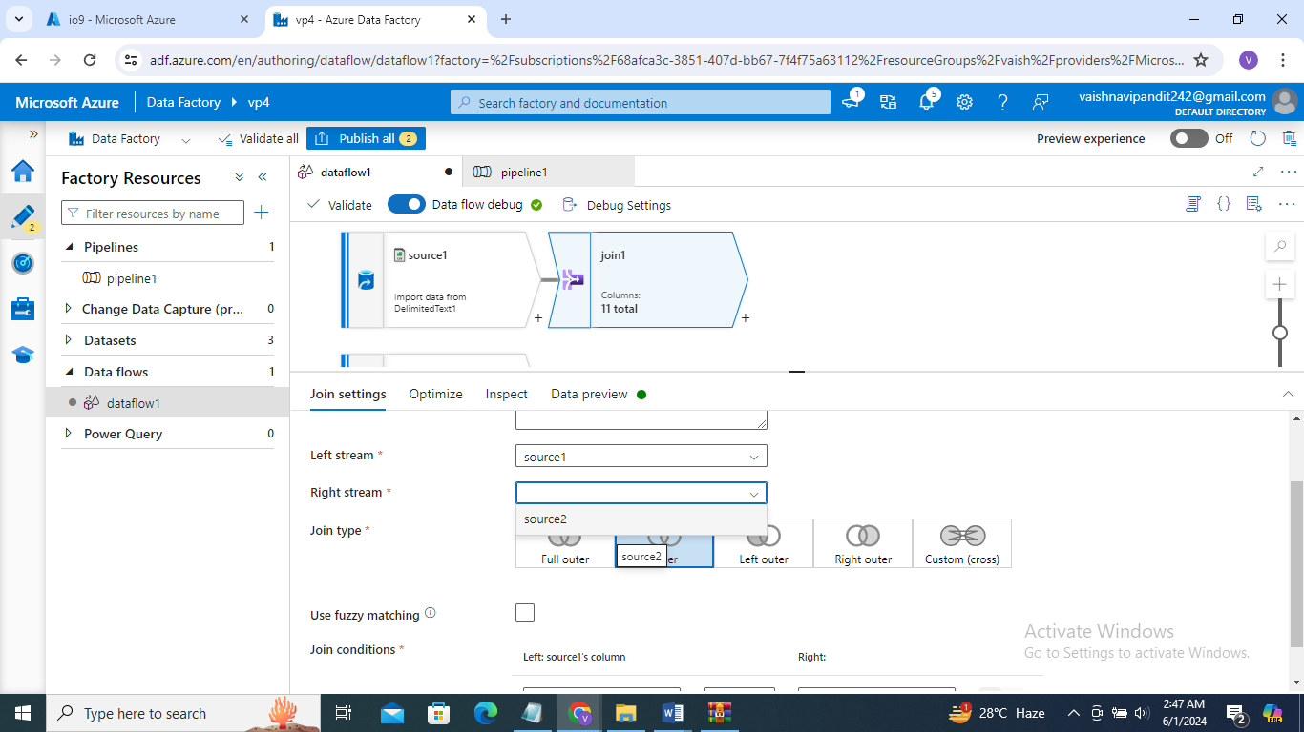

1. Select join type

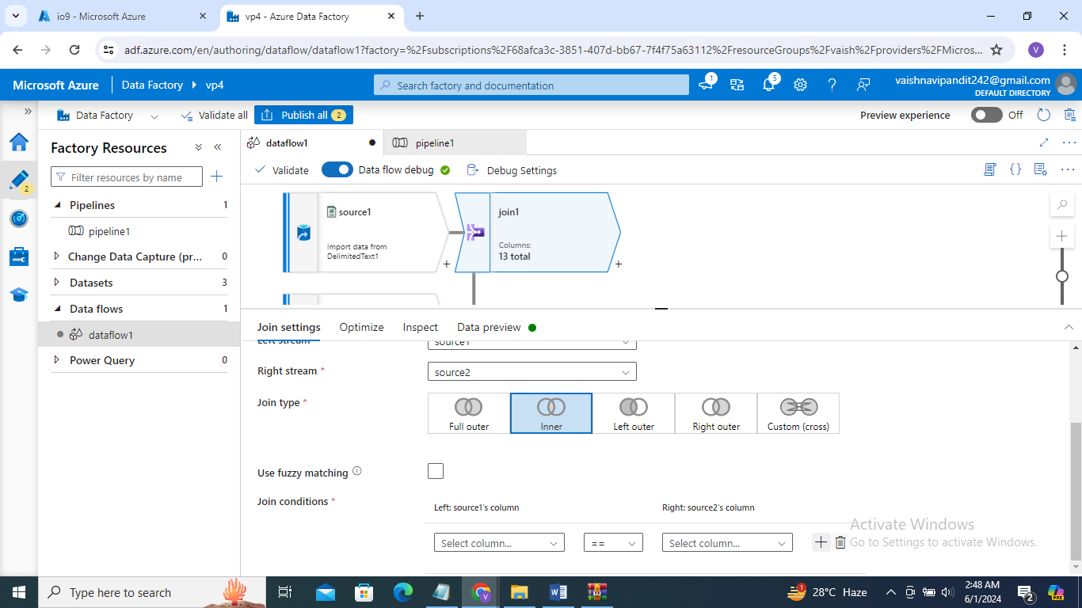

1. Go to join condition add column name on which you want to join and how

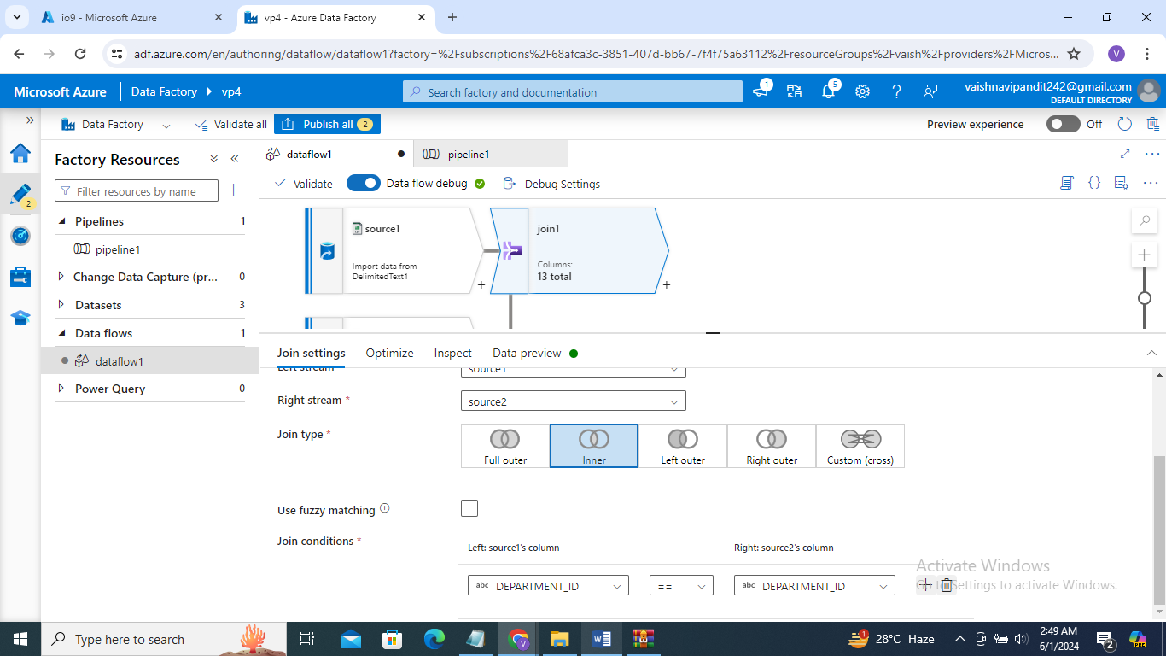

1. That’s it go see preview